Certification Management System

# **Prepared for :**

## **SFDC Training Program**

## **Capgemini Technology Sevices**

# **Prepared By :**

## **Apurv Taunk**

## **Emp Id-46022707**

# **Abstract:**

The Certification Management System is a Salesforce based Application which is used for managing the certification of the employees of the organization. Two profiles use this application namely “App Admin” & “App User”. The App Admin produces the certifications and vouchers for the certification program and the App User connects with the employee for the certification program and generates a certification request in the application which is approved by the App Admin and a voucher is assigned to the certification request. Prior to the approval of the certification request, the App User updates the result of the certification exam given by the employee in the system. Apart from that, this application also has reports and dashboards to give and overall view of the system.

# **Scopes:**

## **Inscope:**

Following are the functionalities provided by the system:

There are two profiles which can access the application: App User & App Admin. Each of them will have their set of operations specified.

1. App Admin:
   1. Create, Edit, Update and Delete Certifications.
   2. Create, Edit, Update and Delete Vouchers.
   3. Approve/Reject Certification Requests.
   4. View and Edit Reports and Dashboards
   5. View the Employees in the system.
2. App User:
   1. Create, Edit, Update and Delete Employees.
   2. Create, Edit, Update and Delete Certification Request.
   3. Update Pass/Fail Status of Employee.
   4. View and Edit Reports and Dashboards
   5. View Certifications and Vouchers in the system.

## **Outscope:**

Following are the functionalities that are not covered by the system:

1. The application doesn’t include employee login.
2. The application is not autonomous.
3. There is no third party integrations involved except for email.

# **Class Diagram:**

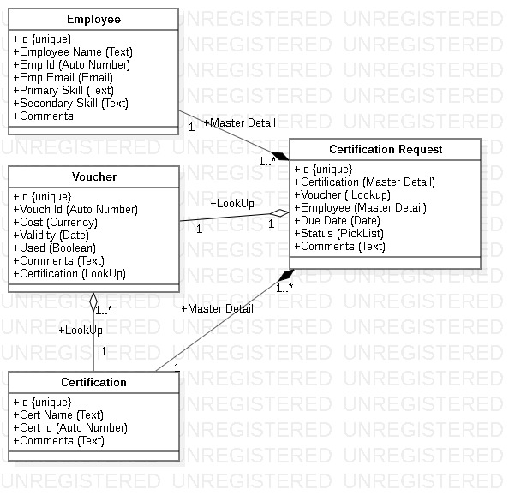

# **Use Case Diagram:**

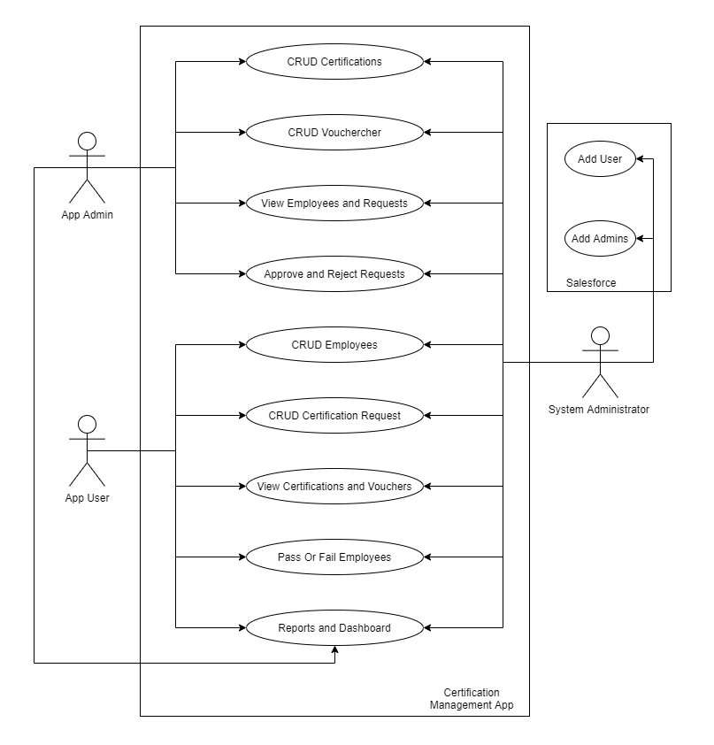

**Activity Diagram (App User):**

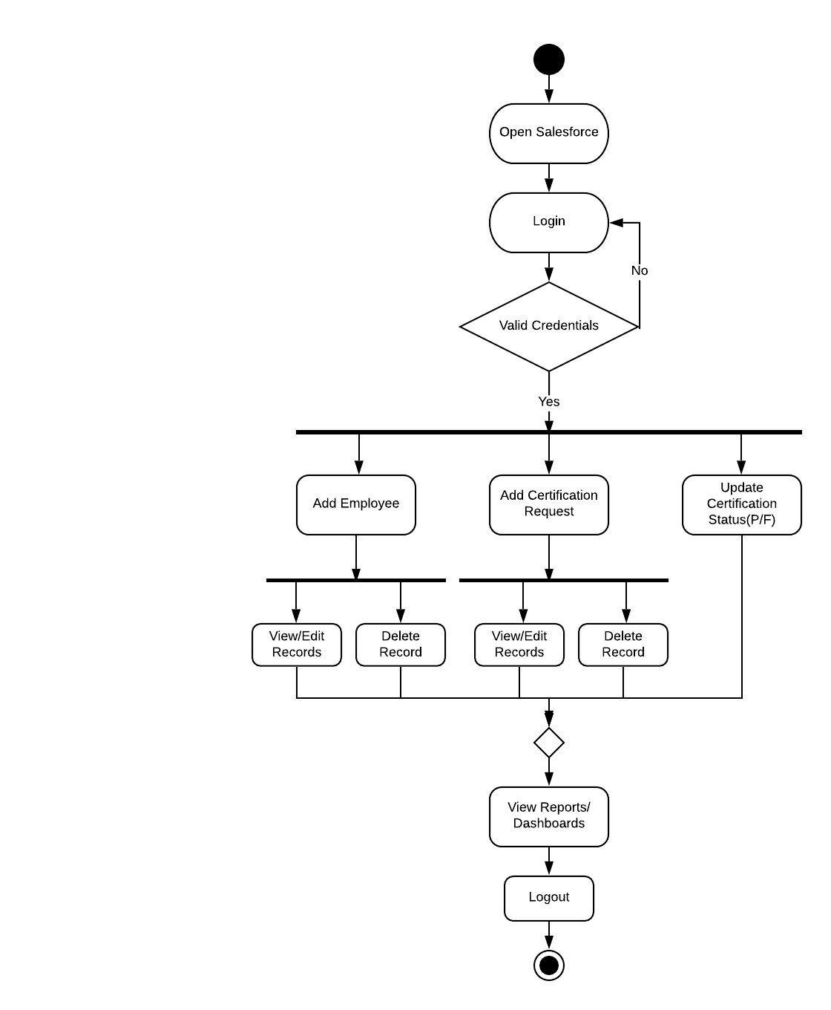

**Activity Diagram (App Admin):**

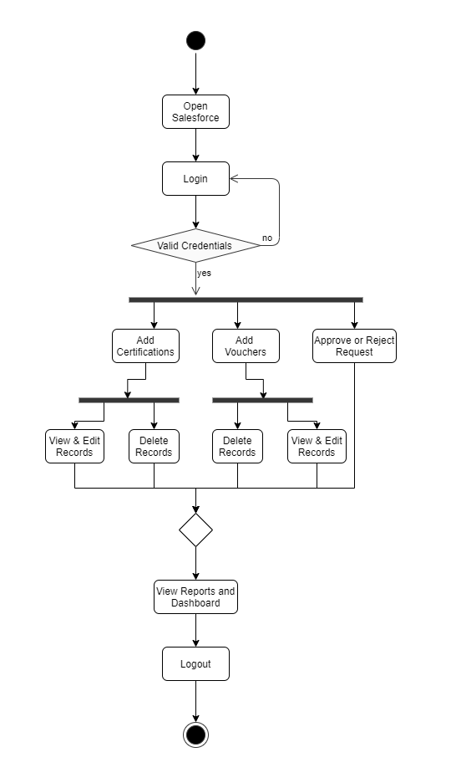

**Sequence Diagram (App Admin):**

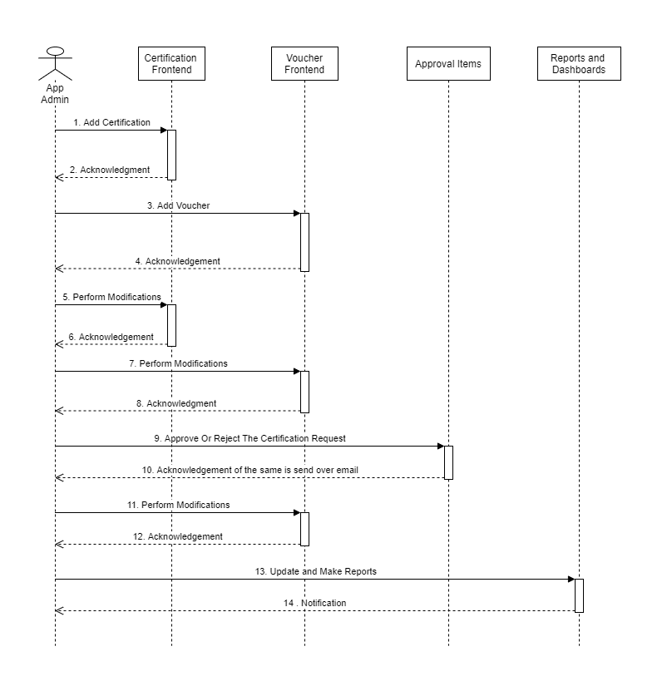

**Sequence Diagram (App User):**

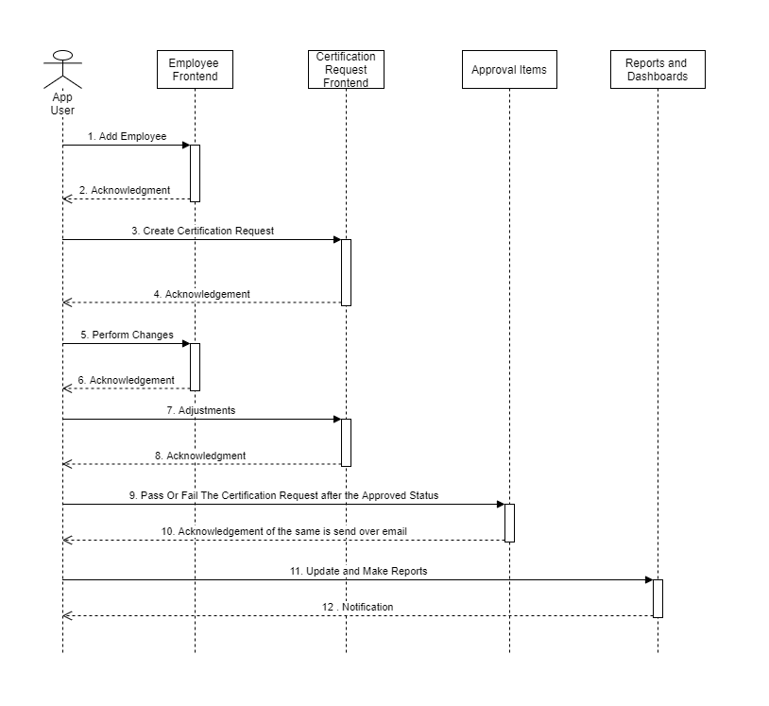

**ERD:**

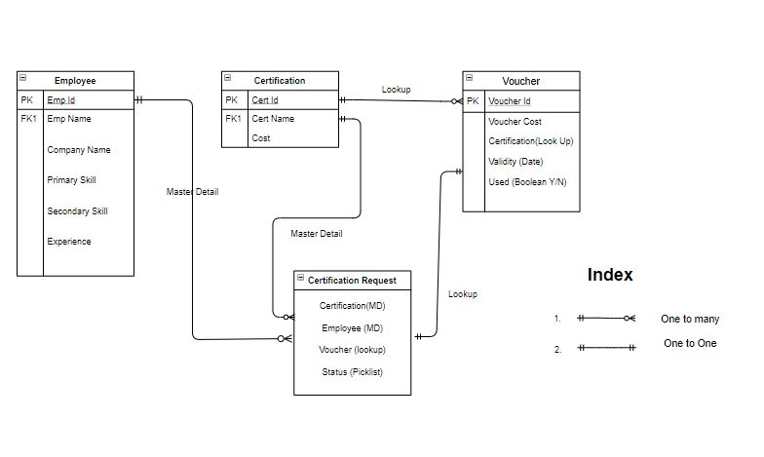

**Class & Methods-Objects**

## Employee Object:

The employee object stores the necessary details of the employees.

Fields:

* Employee Id
* Employee Name
* Employee Email
* Primary Skill
* Secondary Skill
* Experience
* Comments

## Certification Object:

The certification object stores the details of the certification.

Fields:

* Certification Id
* Certification Name
* Comments

## Voucher Object:

The voucher object stores the details of the vouchers.

Fields:

* Voucher Id
* Voucher Cost
* Certification Object (Lookup)
* Validity
* Used
* True
* False
* Comments

## Certification Request Object:

The certification request object stores the request made by the employee for the certification and the status of the request. It stores the relationship between the employee, certification and the voucher. The Certification Request record is created by the App User.

Fields:

* Certification Object (Master Detail)
* Employee Object (Master Detail)
* Voucher Object (Lookup)
* Due Date
* Status
* Draft
* Approved
* Rejected
* Assigned
* Pass
* Fail
* Comments

**Routing – Process & Approval**

## Process Builder:

There is one process builder utilized here. The process builder used is- Employee Process Builder.

*Employee Process Builder* is used to update the record on certification request whenever a record email field changes. This keeps the certification request record updated as the employee gets updated on each approval step via email.

## Approval Process:

There is an approval process in the system which is used to approve the certification request requested by the employee. The approval request is submitted by the App User and the App Admin approves/rejects it.

**Validations**

1. Validity date of voucher must be greater than today.
2. Due date for certification request must be greater than today.
3. No same certification request is allowed for an employee.
4. No new certification requests allowed if any pending request is present for the employee.

**Assumptions**

1. The employee will email the App User for certification request.
2. The employee will send the update for the certification exam given as pass/fail via email.

**Screenshots**

